M&NCFBC CHAMPIONSHIP SHOW 27TH September 2015
Judge: Mr Paul Harding
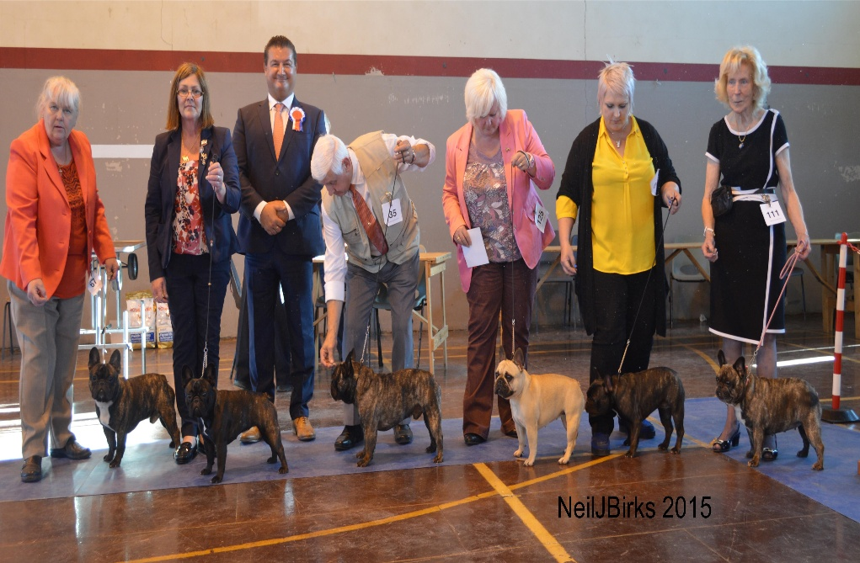

Left to Right: Res. Dog CC Miss Maxwell’s Eastonite Chocolate Chip, Bitch CC & BIS Miss Chambers with her Luvum Minnie Ha Ha, judge Mrs Paul Harding, Dog CC & Res BIS Mr Drummond with his and Mrs Drummond’s Ch. Renuar New War Bonnet Glenlee (Imp Lva), Res Bitch CC Miss A Wildman’s Wildax Dusty Springfield, Mrs L Bonsall with her BPIS Muggshotts Peep Show, and Best Vet in Show Mrs M Souter’s Tommyville Topping at Greusaiche.

MPD 1st: HOGAN Miss D Xentique Pandamonium For Baclaudi 6 months old super front good depth of brisket and bone cat like feet good spring of rib short coupled strong well muscled quarters nice tail set lovely arch of neck and bat like ears lovely expression well filled under the eyes correct bite and good width ofunderjaw moves out with purpose.2nd SMITH Mrs L Bellicose Beetle Juice months old of good type masculine head pleasing dark eye used ears well correct front and brisket very cobby strong well muscled quarters nice tail set moved and handled well. 3rd SMITH & PRATT khanin DxysMidnite Runner
PD 1st HOGAN Miss D Xentique Pandamonium For Baclaudi 6 months old super front good depth of brisket and bone cat like feet good spring of rib short coupled strong well muscled quarters nice tail set lovely arch of neck and bat like ears lovely expression well filled under the eyes correct bite and good width of underjaw moves out with purpose.2nd MONAGHAN Yacanto champagne fever 10 months fawn of standard size good type well balanced sharp outline with correct bat like ears used very well dark eye correct bite good lip placement short and cobby moved with purpose 3rd BROWN Mrs J Forbes De Elka Gyvybes Zyme At Kuredeux
JD 1st MAXWELL Mrs D Eastonite Chocolate Chip `12 months of very good type well balanced stunning outline with correct bat like ears used very well dark eye correct bite good lip placement short and cobby standard dog moved with purpose. 2nd DRUMMOND Mr G & Mrs E Renuar Financial Times Glenlee (Imp) 13 month lovely expression pleasing ears correct front good spring of rib and bone strong well muscled quarters moved and showed well.3rd CLARKE Eastonite Clarke Kent
YD 1st PLEASANCE Ms A Hard Rock Anima Mea At Katakia JW 18 month standard dog typical head and expression used ears well correct bite nice lip placement cobby dog with good front and well muscled quarters moves out well holding top line in profile. 2nd HOWARTH Miss J Gizyjo Rocky Marciano 18 month wonderful head very alert with correct ears good width of underjaw pleasing front and bone strong well muscled quarters moved and handled well.3rd FURBER Carminway Fifty Shades
ND 1st KRALL Mr J & Mrs F Jafrak Much Obliged 11 months old of good type pleasing head and ears used well dark eye and well filled cheeks pleasing neck good spring of rib and bone correct front strong well muscled quarters moved with purpose.2nd MASSEY Mrs T A & Mr D P Frabull's Fidel Castro At Chareve 11 months old masculine head nice dark eye correct bite and good width of underjaw pushed 1 all the way pleasing spring of rib true front well muscled quarters moved and handled well 3rd: RACZKOWSKA Asterix Baskerville Staff-Bull
GD1st:TILLEY Ynnizins Jean-Pierre Papin at Mossport (IMP SWE) 17 month masculine head alert with correct ears good width of underjaw pleasing front and bone standard dog moved and handled well.
PGD 1st: MCMUNN Mr R & Mrs S Goodbull Bob Marley 2 year standard dog typical head and expression used ears well good width of underjaw cobby dog with good front moves out well holding top line in profile.2nd MASSEY Mrs T A & Mr D P Frabull's Fidel Castro At Chareve 11 months old masculine head nice dark eye correct bite and good width of underjaw pushed 1 all the way pleasing spring of rib true front well muscled quarters moved and handled well 3rd:SMITH & PRATT Jafrak Persuade Me at Khanin
MLD 1st:POULSON Mr B & Mrs L Patchdown Pilot JW Sh.CM 2 year old fawn of good type pleasing head and ears used well dark eye and well filled cheeks pleasing neck good spring of rib and bone moved and handled well. 2nd:BURTON Mrs C Rischale Edward Bear Avec Labanjo 2 year old masculine head nice dark eye correct bite and good width of underjaw pleasing spring of rib moved and handled well. 3rd: SOUTER Nokomis Indian Music at Greusaiche
LD 1st:BROWN Mrs J Kuredeux Soul Rebel 2 year old super straight front good depth of brisket and bone cat like feet good spring of rib short coupled strong well muscled quarters nice tail set lovely arch of neck and bat like ears dark eyes well filled under the eyes correct bite and good width of underjaw moves with purpose.2nd MCMUNN Mr R & Mrs S Goodbull Bob Marley 2 year standard dog typical head and expression used ears well good width of underjaw cobby dog with good front moves out well holding top line in profile.3rd: 4 BEALE Mr G Cargray Here Comes The Sun

OD 1st:DRUMMOND Mr G & Mrs E Ch Renuar New War Bonnet Glenlee (Imp) 4 year old good depth of brisket and bone cat like feet good spring of rib short coupled strong well muscled quarters nice tail set lovely arch of neck and bat like ears super dark eyes and lovely expression well filled under the eyes correct bite and good width of underjaw nice lip placement moves out with purpose and drive holding top line in profile and parallel in rear. DCC&RBIS 2nd: MAXWELL Mrs D Eastonite Chocolate Chip 12 months of very good type well balanced stunning outline with correct bat like ears used very well dark eye correct bite good lip placement short and cobby standard dog moved with purpose RCC 3rd:BRADFORD Sibovleds sandro hit
SOFD 1st: HOWARTH Miss J Gizyjo Rocky Marciano 2nd:POULSON Mr B & Mrs L Brandoux Valentinoux at Patchdown 4 year old short and cobby lots of rib and correct top line correct ears moved and handled well. 3rd:SMITH & PRATT Jafrak Parisian Dandy at Khanin
SOBD 1st:MAXWELL Mrs D Eastonite Chocolate Chip 2nd: MASSEY Mrs T A & Mr D P Frabull's Fidel Castro At C.3rd SOUTER Nokomis Indian Music at G
MPB 1st:SWATERIDGE Mr R & Mrs C Xentique Total Eclipse 6 month old feminine head and dark eye correct bite and lip placement bat like ears used well straight front good spring of rib with short couple lovely top line moved out well.2nd:SEFFER Miss S Catrelma Cottati Coutier 8 month pleasing head feminine expression correct ears good spring of rib nice top line went well on the move 3rd:MORGAN, Miss J & LING Mr G Tytorro Biba Amoureuse
PB 1st BONSALL Mrs L J Muggshotts Peep Show 9 month old lovely feminine head and dark eye giving that typical expression correct bite and lip placement bat like ears used well correct straight front good spring of rib with short couple nice tail set and well muscled quarters moves with purpose.BPIS DAVIS Miss S Rowendale Peanut Butter 8 month feminine head pleasing ears used well correct bite and good width of underjaw good spring of rib and bone moved and handled well.3rd: HOLLAND Jint Jims Fancy Nancy
JB 1st:WILDMAN Miss M A Wildax Princess Tippy Toes 15 month feminine head pleasing expression correct ears used well correct bite good lip placement correct neck good spring of rib and bone nice straight front lovely top line moved and handled well. 2nd:PEARCE Mrs S Tillcarr Lipstick Floozie 15 month super head full of expression correct ears good spring of rib and short coupling nice top line went well on the move 3rd: WALL & WEBB Rowendale Flower Pot
YB 1st: CHAMBERS Miss S Luvum Minnie Ha Ha 17 month old sweetest expression big lovely dark eyes good width of underjaw correct bite and lip placement well padded lips correct ear set working at all times strong neck and well muscled shoulders cat like feet pleasing bone good spring of rib short coupling strong well muscled quarters moves out with purpose and drive holding top line in profile and parallel in front and rear. CC&BIS. 2nd: PLEASANCE Ms A Impressive Lady Kurazh Elit For Katakia 12 months old pleasing head correct bite good width of underjaw good lip placement correct neck good spring of rib and bone moved and handled well.3rd: SMALL Norcairns Guardian Angel Avec primaries
NB 1st: SWATERIDGE Mr R & Mrs C Xentique Total Eclipse 2nd:PLEASANCE Ms A Impressive Lady Kurazh Elit For K.
3rd: DAVIS Miss S Rowendale Plum Pudding
GB 1st: ROACH Miss L Roalice Mini Mouse 17 month feminine head dark eye giving that typical expression correct bite and lip placement bat like ears used well good spring of rib and bone nice straight front lovely neat feet moved and handled well. 2nd SOUTER Mrs M E Tommyville Topping at Greusaiche 9 years old standard girl lovely head and ears well off for bone and good spring of rib just a touch loose on the front as one would expect at this age.BVIS
PGB 1st WALLACE Mrs J Ardhub Tickle And Tease Me at Braylah 14 months old short and cobby lots of rib and correct top line correct ears used to show off that lovely feminine head nice tail set and well muscled quarters moves with purpose.
nice nice SMITH & PRATT Jafrak Never Persuaded at Khanin 22months old standard girl lovely head and ears correct front well off for bone and good spring of rib moved and handled well.3rd: HENDERSON Bumbledor Pyxi
BML 1st: SOUTER Mrs M E Tommyville Tartan Ribbon at Greusaiche shCM 4 years old feminine head very expressive dark eyes correct bite and good width of underjaw correct ears true on the front good spring of rib pleasing top line moved with purpose.2nd:BROOKS, Mr J R & CAIRNS Mr R J Barilballe Fifis Prima With Corursus Sh.CM 2 year old feminine head and expression correct ears used well correct front and top line correct spring of rib moved out well. 3rd SMITH Mr M G & Mrs T Rischale Ophelia
LB 1st:ESPOSITO Miss M Jafrak La Di Da Ossidcla 2 year old feminine head very expressive eyes correct bite and good width of underjaw correct ears true on the front good spring of rib nice top line and tail set moved with purpose.2nd:DAVIS Miss S Rowendale Teacake 2 year old super head and expression correct ears used well correct front and top line pleasing spring of rib moved out well with drive on the move.3rd: SENIOR Mrs A Kingrock Maple Syrup With Theapaul
OB 1st:WILDMAN Miss M A Wildax Dusty Springfield 3 year old feminine expression lovely dark eyes correct bite and lip placement well padded lips correct ear strong neck and well muscled shoulders short coupling pleasing top line strong well muscled quarters and nice tail set held top line on the move with a lovely parallel action RCC.
2nd:KRALL Mr J & Mrs F Jafrak Doramaar 3 year old feminine expression lovely dark eyes correct bite and lip placement well padded lips correct ear strong neck and well muscled shoulders good spring of rib short coupling strong well muscled quarters and nice tail set moved with a lovely parallel action. 3rd:MASON CH Aprika Miss World JW shCM
VB 1st:SOUTER Mrs M E Tommyville Topping at Greusaiche .
BVIS
SOPB 1st:WELSH Feniton Farthing 6 year old feminine head and dark eye correct bite and lip placement correct straight front good spring of rib with short couple lovely top line and roach nice tail set and well muscled quarters moved with purpose 2nd:HOZA Xentique Fun and Games 6 month old feminine head correct bite and lip placeme
nt ears used well straight front good spring of rib with short couple moved out well.3rd:ABBOTT Haute Couture Mademoiselle Chanel la Frenchies (IMP USA)
SOFB 1st:SHARKEY Missy Moo at Maxibulz 19 months old of good type and size feminine head expressive eyes correct bite and good width of underjaw pleasing ears and front good spring of rib pleasing top line and tail set moved out with purpose.2nd:SOUTER Mrs M E Tommyville Tartan ribbon at Greusaiche shCM 3rd: CHAMBERS, Miss S & DRUMMOND Mrs E Glenlee Eternal Flame Luvum
SOBB 1st:ESPOSITO Miss M Jafrak La Di Da Ossidcla 2nd:WALLACE Mrs J Ardhub Tickle And Tease Me at B 3rd: SWATERIDGE Mr R & Mrs C Xentique Burlesque.

